**Tutorial -SQL Exercises 1**

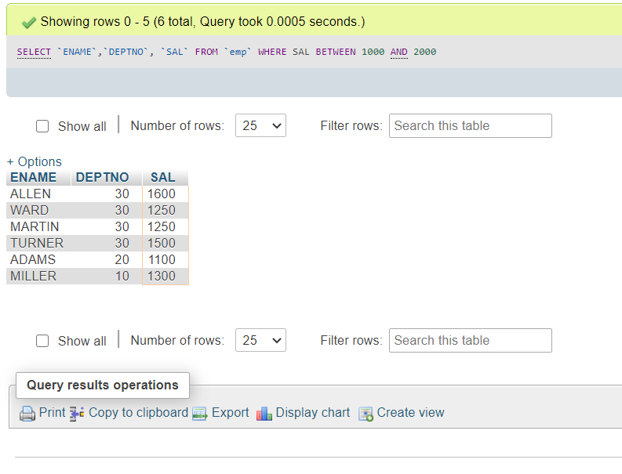1. **List all the employees whose salary is between 10000 and 2000. Show employee name, dept. and salary**

2. **Display all the different types of occupations**

With the DISTINCT key word we can avoid the duplication. 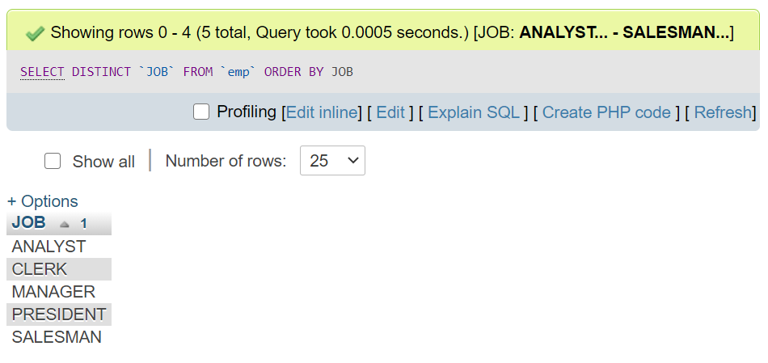

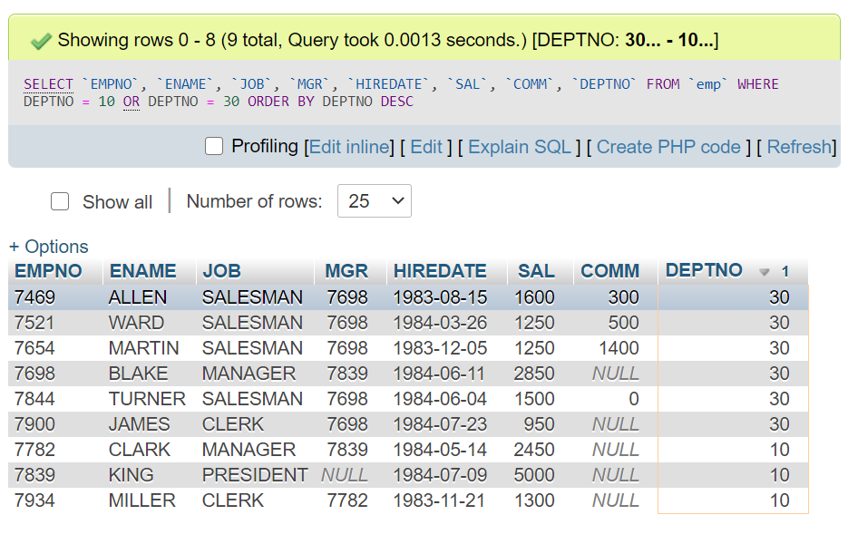3. **List details of employees in departments 10 and 30**

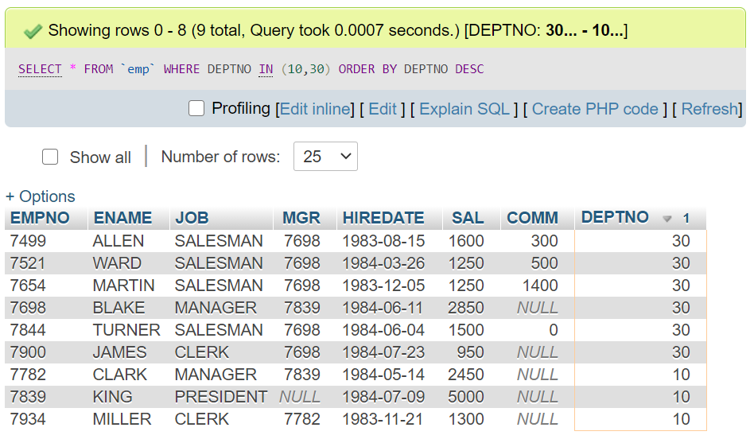**2ND METHOD**

4**. Display all employees who were recruited during 1983, giving their name, dept. and hire-date**

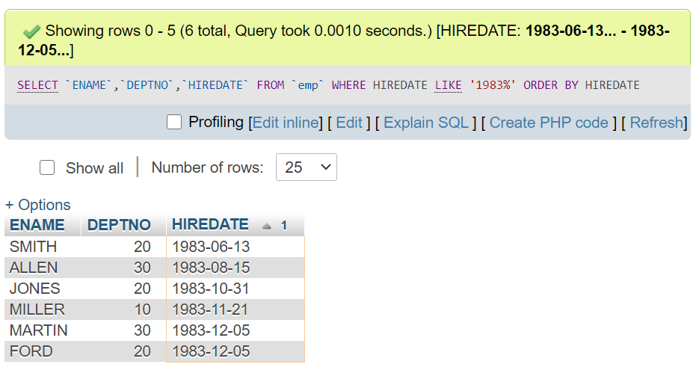ORDER BY HIREDATE is used to take date in ascending order to know whether an attribute value matches a string value------- LIKE is used

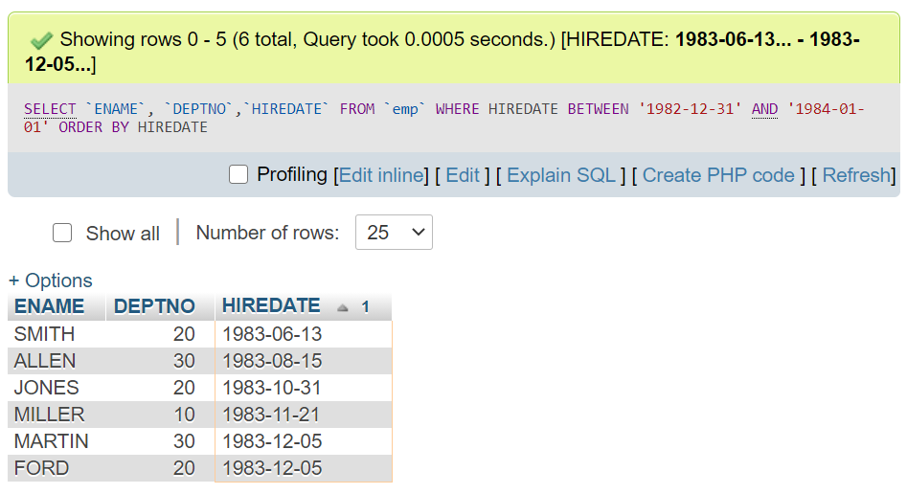2ND METHOD

5. **List the names and jobs of all clerks in department 20**

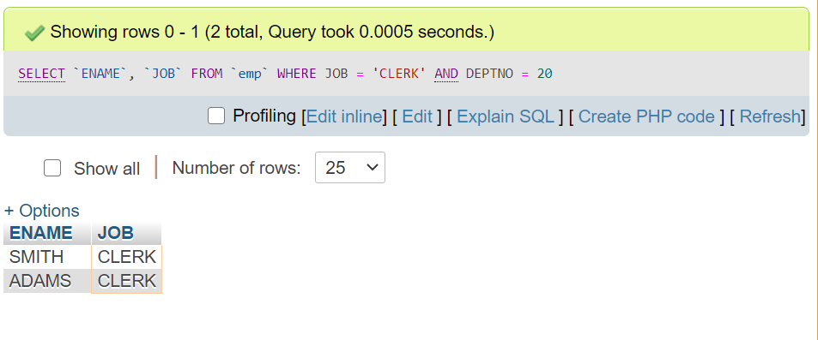

6. **List the employees whose names have TH or LL in them**

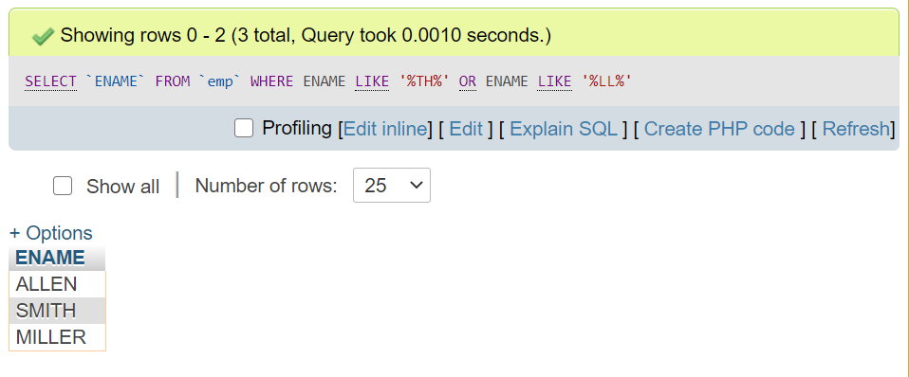

7. **List the department numbers and names in department name order.**

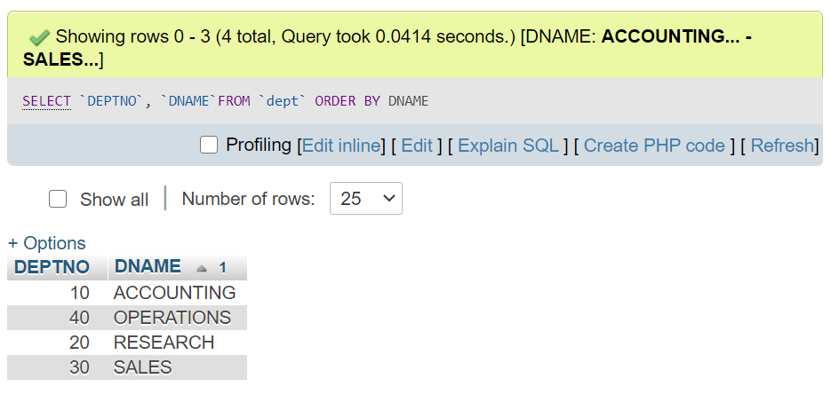

8. **List all the information in a table called SALGRADE**

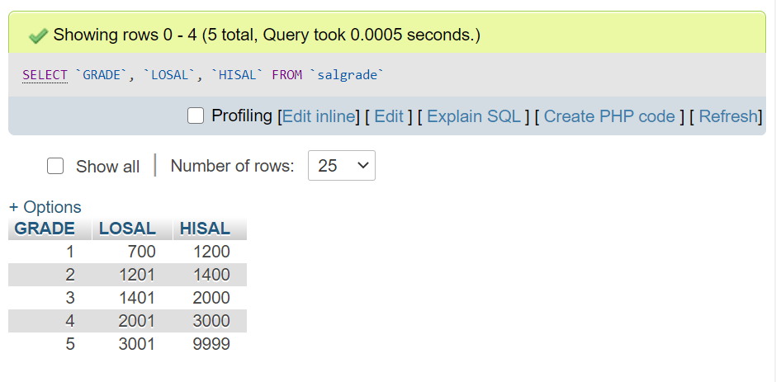

9. **Find the names, jobs, salaries and commissions of all employees who do not have managers**

